## horizontal line



AI Movie Recommender System

15.01.2022

**─**

Chris Mutua

JKUAT Main Campus

P.O. Box 764

Juja

# Acknowledgment

This section is hereby written to recognize and appreciate the efforts of all those who participated in helping this project to come to be. These include:

* Professor Mulang’ – JKUAT Main campus lecturer. He also participated as the overall project manager

# Preface

This project was inspired by my friends who have always challenged me on creating projects integrating the latest technology as well as making it useful to the end-users. When the opportunity arose, this was the project in mind hence its implementation made me realize my goal.

# Project Overview

The system in reference, The AI Movie Recommender System, is a software system that uses Artificial Intelligence to determine related movies based on the searched one. It relates movies to others in a given data-set based on the actors, ratings, genre, year, remarks among many other things. It displays the recommendations and also more information about the current movie.

# 

# Table Of Contents

**Acknowledgment** **1**

**Preface** **1**

**Project Overview** **1**

**Table Of Contents** **2**

**Project Requirements** **3**

Hardware 3

Software 3

Liveware 3

**Source Code Documentation** **4**

**Project Structure** **4**

Contents 5

**Project Setup and Configuration** **6**

**Project Setup and Configuration Run and Access the Project** **9**

**Project UI Appearance** **9**

Main Page 9

Recommendations Webpage 10

User Interface Design 19

**Help and Maintenance** **20**

**References** **21**

# 

# Project Requirements

As for the system, the following are the least hardware, software, and liveware requirements for the system to run smoothly:

## Hardware

* Quadracore Processor with a base frequency of 2.0GHz (This enables the system to quickly create relations of the current searched movie title with the others in the datasets)
* 4GB Ram (This will support any background processes)
* Network Card (Well connected to the internet for quick dependency installation and data-set updating)

## Software

* Operating System:- Windows 10, Ubuntu, Mac OS, Virtual Environments
* Environment Setup:- Python installation

## Liveware

* As for the System Administrators, knowledge of python and its frameworks is a requirement.
* For the End-Users, just basic browsing knowledge is required.

# 

# Source Code Documentation

The application Software is made using Python, and the web pages are made using HTML and finally styled using some CSS.

**FLASK** web framework was used to develop the application in Python. This is because of its simplicity and its small size. This size makes it easy for one to handle the whole project quickly.

# Project Structure

The Project consists of the following folder and file structure:

* Datasets (folder)
* Documentations (folder)
* Screenshots (folder)
* Static (folder)
* Templates (folder)
* main_data.csv (file)
* main.py (file)
* nlp_model.pkl (file)
* Procfile (file)
* README.md (file)
* requirements.txt (file)
* transform.pkl (file)

The project structure is as shown in the image below:

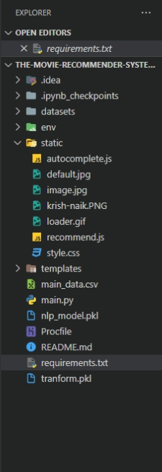

## Contents

* Datasets (folder):- Contains movie datasets from IMDB, The Movies Dataset, List of movies in 2018, List of movies in 2019, and List of movies in 2020.
* Documentations (folder):- This folder contains documentation for the project. The documentations cover the structure and overall functionality of the project. It also contains API_KEY both as text and as a screenshot.
* Screenshots (folder):- This folder has actual screenshots of the working system. It also has screenshots of the project structure.
* Static (folder):- The folder contains the webpage styling, loader GIF, background images, autocomplete code (this searches for related titles based on the searched one and gives suggestions for one to select). The files found here therefore include:
  + - autocomplete.js
    - default.jpg
    - image.jpg
    - Krish-naik.png
    - loader.gif
    - recommend.js
    - style.css
* Templates (folder):- The webpage skeletons are found here. These are used as templates to generate static websites based on the data provided. The files found here include:-
  + - home.html
    - recommend.html
* main_data.csv (file):- This provides a set of movie cast names, director names, genres, and movies related to it. This creates a comb that enables the system to create new relationships to the current data.
* main.py (file):- The file that initializes the program
* nlp_model.pkl (file)
* Procfile (file)
* README.md (file)
* requirements.txt (file)
* transform.pkl (file)

# Project Setup and Configuration

This step takes care of the project the installation and the setting up.

To start, first, do the installation of the environment and dependencies. Follow these steps:

Open up the terminal on the project folder.

Execute the following command to create the environment for the project:

python -m venv env

Once run successfully, it creates a new folder known as env which has the environment files.

Activate the environment using the following command:

./env/scripts/activate

These commands prevent the installation of the dependencies found in the requirements.txt file in the whole system especially when there is more than one project installed and set up on the computer. Doing so prevents conflicting dependencies.

Do installation of the dependencies found in the requirements.txt file by running the command below:

pip install -r requirements.txt

Wait for the full installation process which may take some time depending on the internet speed.

Make sure that the API_KEY is well set up in the recommend.js file that uses them to fetch data on the TMDB site. The API_KEY for this project created by the programmer is as seen below:

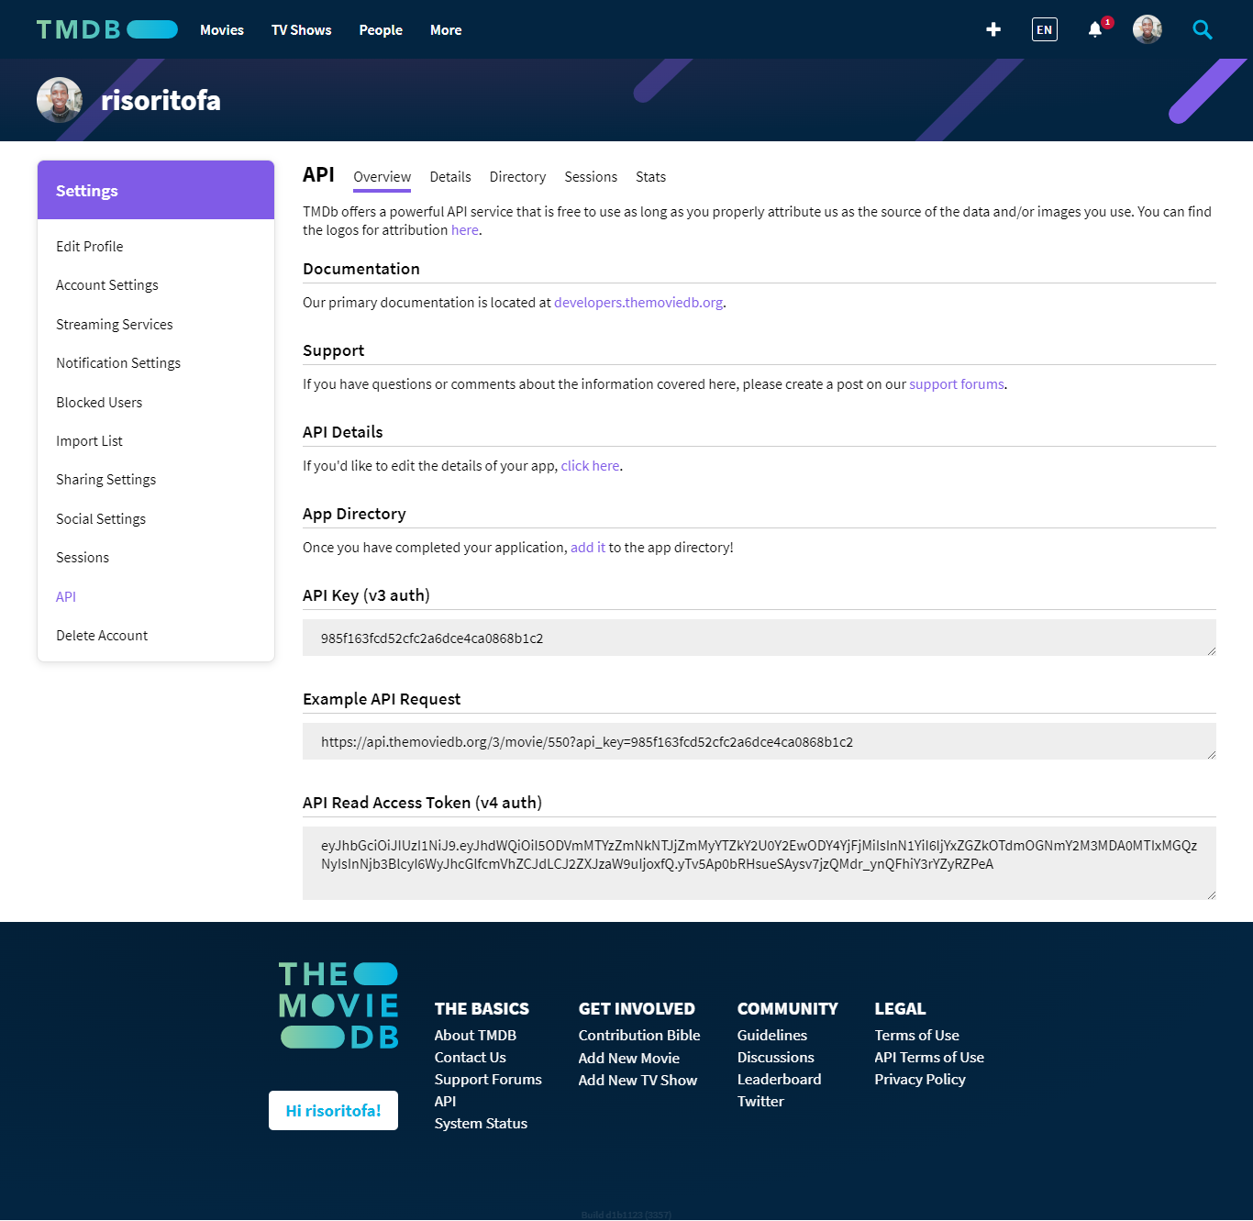

**985f163fcd52cfc2a6dce4ca0868b1c2**

The key above is already put in the project. If it’s not set up, make sure it is copied and pasted in the recommend.js file in the section represented by the API_KEY word in lines 23 and 43 of the code.

# Project Setup and Configuration Run and Access the Project

To run the project, execute the following on the terminal:

python main.py

This command runs the project via the project entry point.

Access the project via a web browser using the following URL:

<http://127.0.0.1:5000/>

# Project UI Appearance

## Main Page

The project main page (home.html) skeleton looks as follows:

The main page after successful project run, styling, and conversion into a static webpage by the framework look as shown in the image below: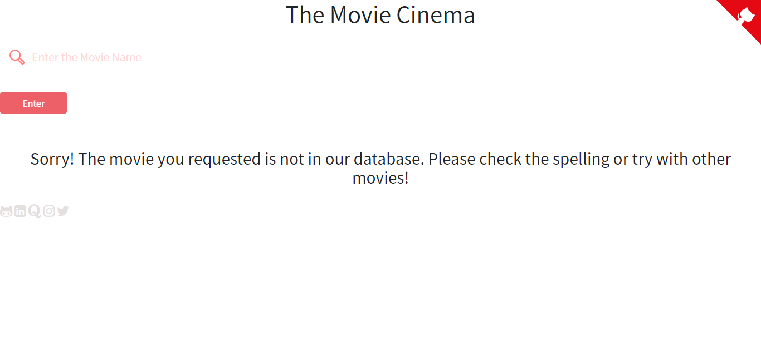

When the dialogue box is dismissed, the user is presented with the screen below where they can interact with the system.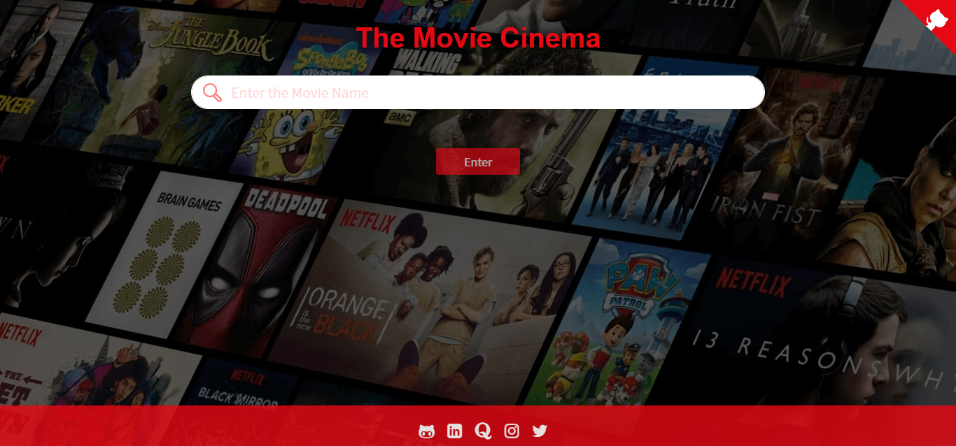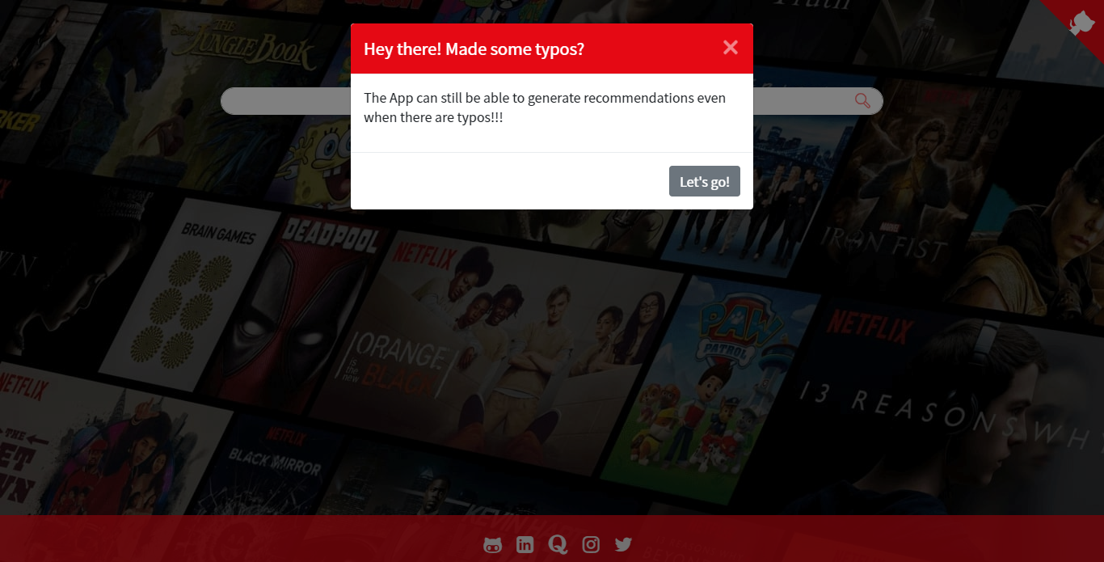

## Recommendations Webpage

The skeleton appearance of the Recommendations Webpage (recommend.html) is as follows based on its code before running the project:

Once the project is run, it uses the template above to generate a website page with the fetched data. Check it out in the image shown below: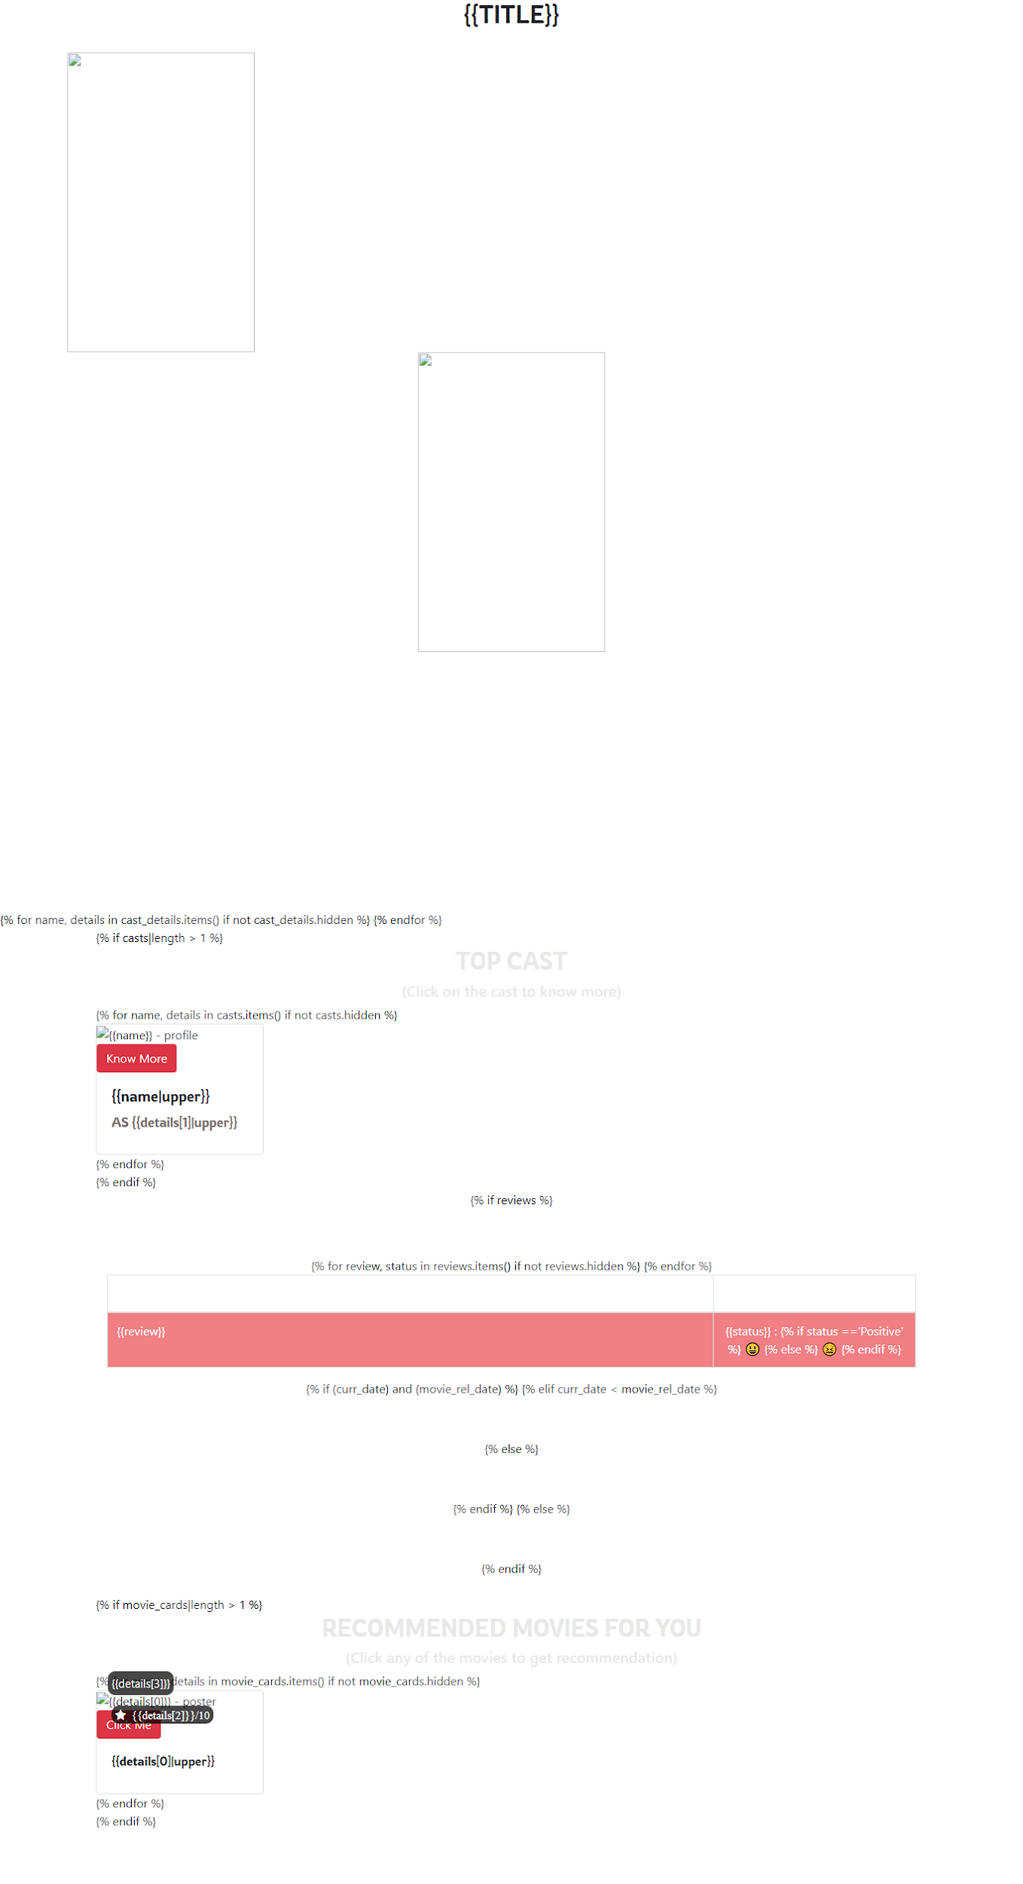

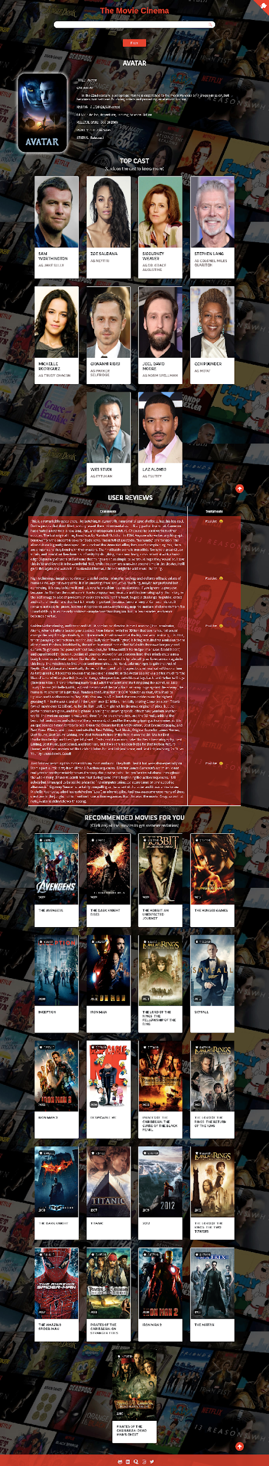

If no item is found, the following will be returned by the system:

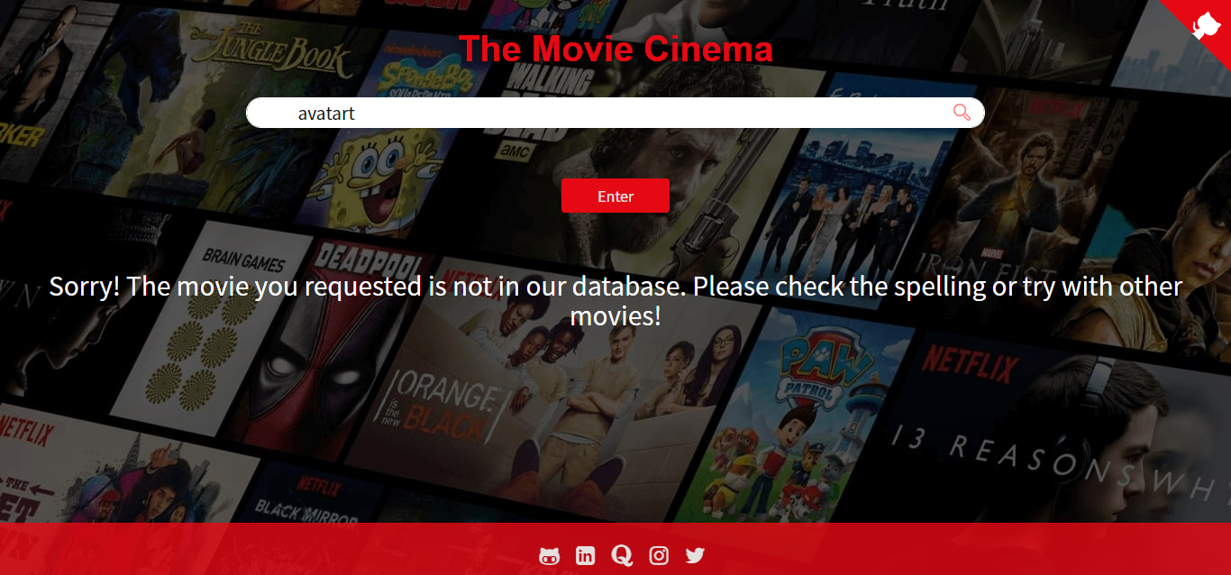

All requests are well tracked on the terminal on which the main application is executed on. Open the terminal side to side with the browser and run searches. One will quickly notice that on each search, a request is displayed on the terminal. Check it out as shown in the terminal below:

This helps in monitoring the system from its deployment to its failure, hence one can know the causes of system failure.

http://127.0.0.1:5000/

It displays a webpage with a dialogue box as shown in the image below:

Dismiss the dialogue box(modal) by clicking on the close button or the ‘Let’s go!’ button. This action makes it display the search bar as shown below:

Click on the search bar and begin typing the name of the movie in which you want to check related recommendations to it. This step is shown below with a sample search:

Select the options autocompleted by the system based on the ones available on the data set. One can also click on the **Enter** button to perform the search. The search can be performed whether the movie being searched for is found on the data-set or not.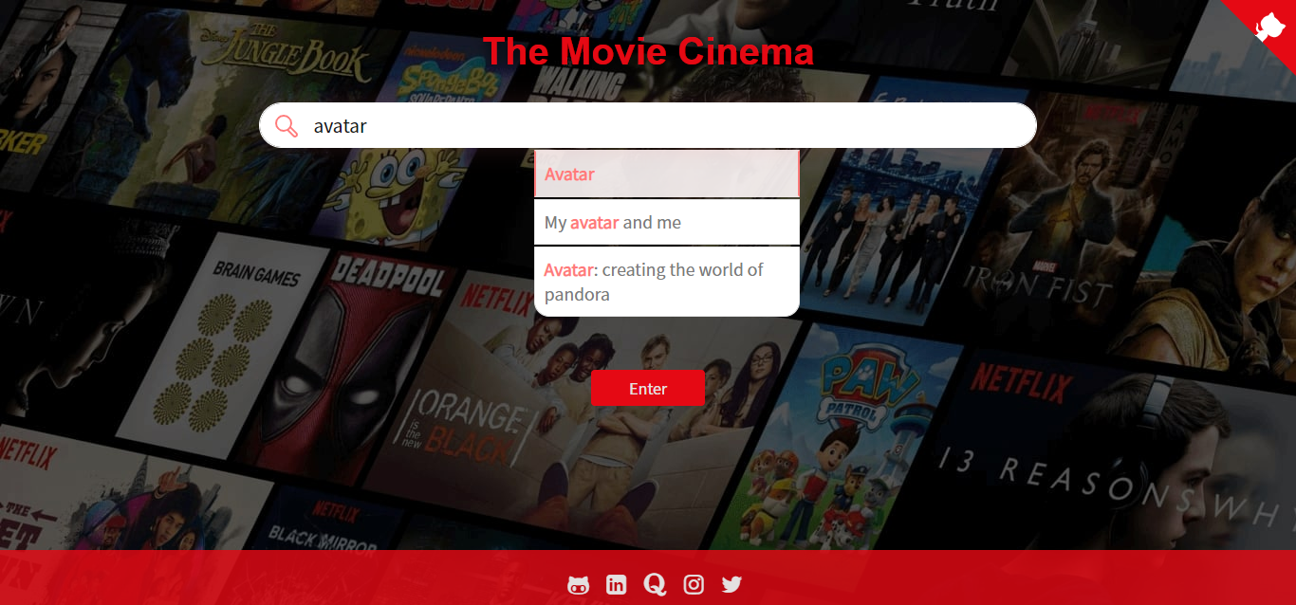

Once the search action is in execution, the program shows the loading animation as shown below:

It then displays content based on the searched-for movie. An example is shown in the image below:

In case of errors, the following will be the application response:-

This shows that the item isn’t found.

## User Interface Design

* The user interface has been designed to mainly have two pages. These are used so that the user may not need to scroll much but find all needed contents at their fingertips.
* It also has impressive colors which prevent straining while promoting consistency to the site.
* The website also has minimum features to prevent confusion and over-cramming of the contents of the site.
* The website uses input search recommendations so that it can minimize the number of errors generated. It also allows it to handle errors in an acceptable way.

# Help and Maintenance

As for the project maintenance, the following can be performed:

1. Update the CSV file by downloading it through the following website: https://www.kaggle.com/carolzhangdc/imdb-5000-movie-dataset
2. Update the datasets found in the Dataset folder by downloading them to the following sites: <https://www.kaggle.com/carolzhangdc/imdb-5000-movie-dataset>

https://www.kaggle.com/rounakbanik/the-movies-dataset

https://en.wikipedia.org/wiki/List_of_American_films_of_2018

https://en.wikipedia.org/wiki/List_of_American_films_of_2019

<https://en.wikipedia.org/wiki/List_of_American_films_of_2020>

1. Clear the successful requests on the terminal so that it can be easy to follow up on the new ones. It also frees up the RAM for better performance of the system.
2. In case of expired API_KEY, generate a new one by visiting the official IMDB site found here: https://www.themoviedb.org/
3. Replace the old ones so that the new ones can allow one to use the application.

# References

1. The IMDB Website: <https://developer.imdb.com/>
2. TMDB Site Documentation: <https://www.themoviedb.org/documentation/api>
3. Kaggle site for free Datasets: <https://www.kaggle.com/>
4. Movie Recommender System blog by Great Learning Team: <https://www.mygreatlearning.com/blog/masterclass-on-movie-recommendation-system/>